**CRC Cards**

|  |  |
| --- | --- |
| User | |
| Responsibilities:  -> Login system using credentials  -> Add buyer details  -> View and Search Cars from Inventory | Collaboration:  -> Invoice  -> Inventory  -> Car  -> Buyer |

|  |  |
| --- | --- |
| Inventory | |
| Responsibilities:  -> Save capacity of warehouse  -> Store quantity and details of each car | Collaboration:  -> User  -> Car |

|  |  |
| --- | --- |
| Invoice | |
| Responsibilities:  -> Show price  -> Show customer details | Collaboration:  -> User |

|  |  |
| --- | --- |
| Buyer | |
| Responsibilities:  -> Give Personal Details  -> Select Car  -> Buy Car  -> Pay Money and receive Invoice | Collaboration:  -> User  -> Car |

|  |  |
| --- | --- |
| Car | |
| Responsibilities: | Collaboration:  -> User  -> Inventory  -> Buyer |

|  |  |
| --- | --- |
| Owner | |
| Responsibilities:  -> Add new employees  -> Add cars in inventory  -> Generate sales Report  -> Login system using credentials  -> Add buyer details  -> View and Search Cars from Inventory | Collaboration:  -> User  -> Inventory  -> Car |

|  |  |
| --- | --- |
| Employee | |
| Responsibilities:  -> Login system using credentials  -> Add buyer details  -> View and Search Cars from Inventory | Collaboration:  -> User  -> Owner |

**Use Case Scenarios**

**Scenario 1**

System: Car Dealership Management System

Use Case Name: Login Use Case No.: UC-01

Participating Actors: Employee, Owner

Pre-Conditions: Actor must already have login credentials.

Post-Conditions: Login Credentials will be filled and verified.

Main Flow: 1. Actor will enter login credentials.

2. Actor will press Login Button.

3. Credentials will be verified and then access will be granted.

Alternate Flow: If credentials are wrong an error will be displayed.

**Scenario 2**

System: Car Dealership Management System

Use Case Name: Add New Employee Use Case No.: UC-02

Participating Actors: Owner

Pre-Conditions: Actor must be logged in.

Post-Conditions: New employee will be registered and he/she will receive login credentials.

Main Flow: 1. Actor will press Add New Employee Button.

2. Actor will fill out the employee details.

3. Actor will create credentials for employee and give it to them.

Alternate Flow: If credentials already exist then error will be displayed.

**Scenario 3**

System: Car Dealership Management System

Use Case Name: Add Cars in Inventory Use Case No.: UC-03

Participating Actors: Owner

Pre-Conditions: Actor must be logged in.

Post-Conditions: Car details will be added in the database.

Main Flow: 1. Actor will press Add Car Button.

2. Actor will fill out car details in a form.

3. Car details will be added.

Alternate Flow: Car is already present in the database and Inventory, so error displayed.

**Scenario 4**

System: Car Dealership Management System

Use Case Name: Search and View Cars Use Case No.: UC-04

Participating Actors: Owner, Employee

Pre-Conditions: Actor must be logged in, Car must exist in database.

Post-Conditions: Actor will be able to view car details.

Main Flow: 1. Actor will press Search icon.

2. Actor will enter car model or color.

3. Cars will be displayed.

Alternate Flow: Data entered in search bar is incorrect, so error will be displayed.

**Scenario 5**

System: Car Dealership Management System

Use Case Name: Update car details Use Case No.: UC-05

Participating Actors: Owner

Pre-Conditions: Actor must be logged in, Car must exist in database.

Post-Conditions: Actor will be able to update car details.

Main Flow: 1. Actor will press Update Car Button.

2. Actor will update the details.

3. Details will be stored in database.

Alternate Flow: If details are incorrect, then error will be displayed.

**Scenario 6**

System: Car Dealership Management System

Use Case Name: Add Buyer Details Use Case No.: UC-06

Participating Actors: Owner, Employee

Pre-Conditions: Actor must be logged in, Buyer details must be known.

Post-Conditions: Actor will add the buyer to the database.

Main Flow: 1. Actor will press Add Buyer Button.

2. Actor will fill the form of Buyer Details.

3. Details will be verified and stored in database.

Alternate Flow: If details are incorrect or are incomplete, then error will be displayed.

**Scenario 7**

System: Car Dealership Management System

Use Case Name: Generate and View Sales Report Use Case No.: UC-07

Participating Actors: Owner

Pre-Conditions: Actor must be logged in.

Post-Conditions: Actor is able to view sales report of the dealership.

Main Flow: 1. Actor will press Generate Report Button.

2. Actor will enter the month and year of which duration report is needed.

3. Report will be downloaded on the device.

Alternate Flow: If report cannot be generated, then error will be displayed.

**Use Case Diagram**

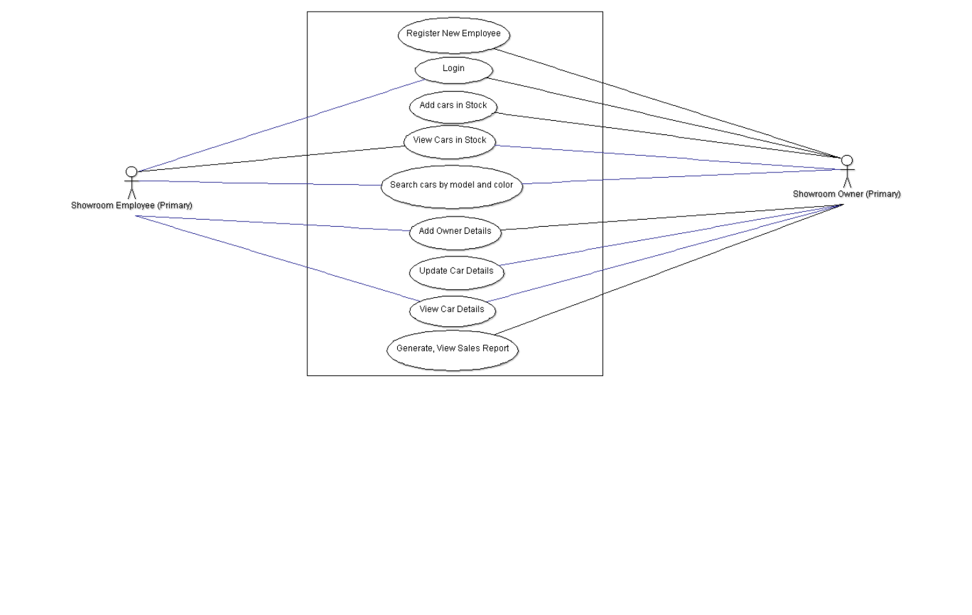

**Expanded Use Case Diagram 1**

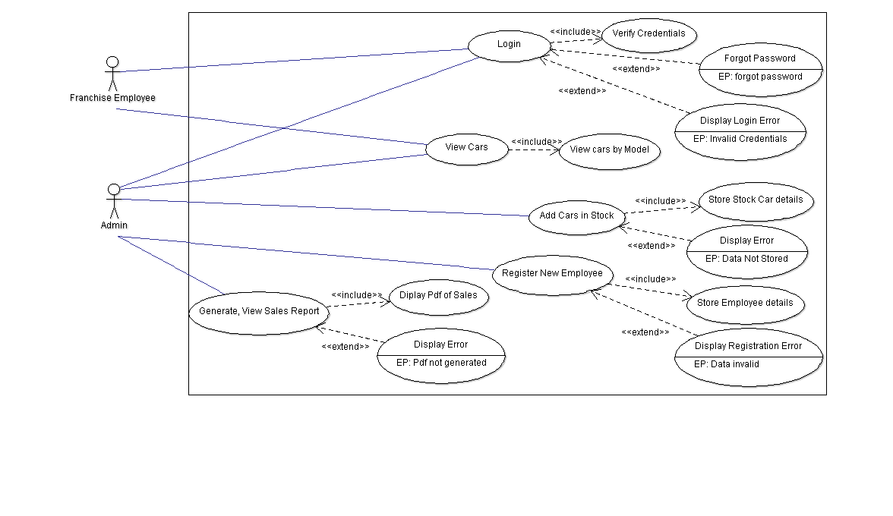

**Expanded Use Case Diagram 2**

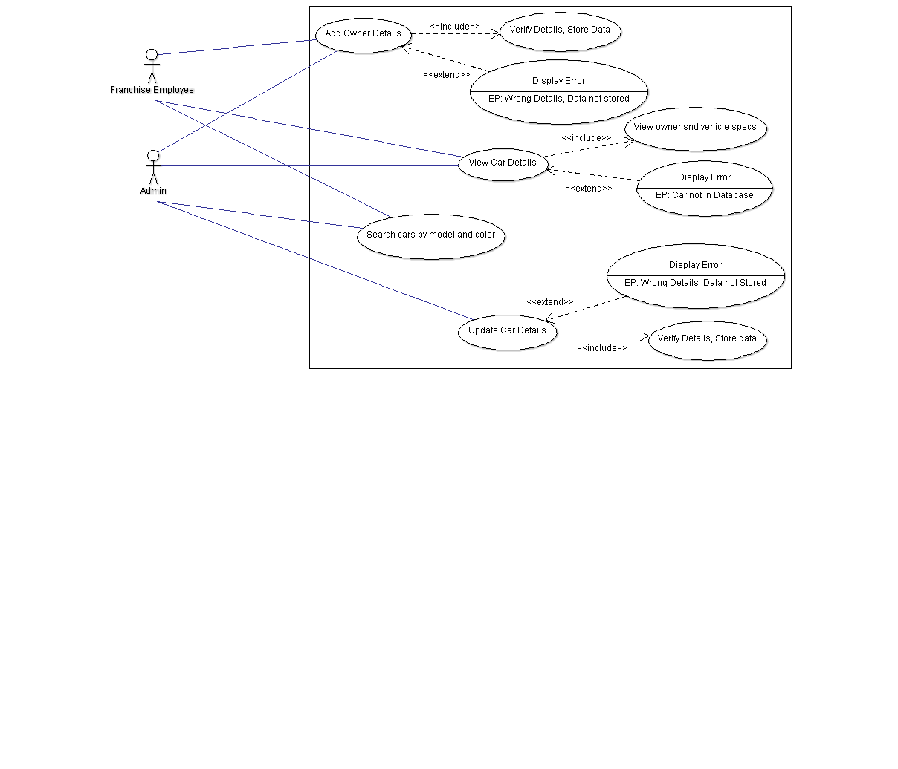

**Class Diagram**

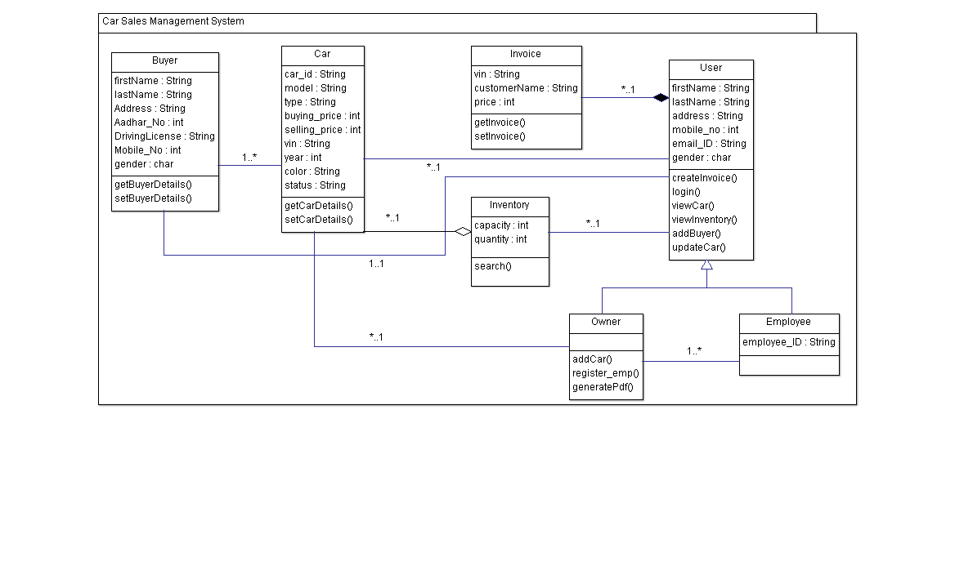

**Analysis Class Model**

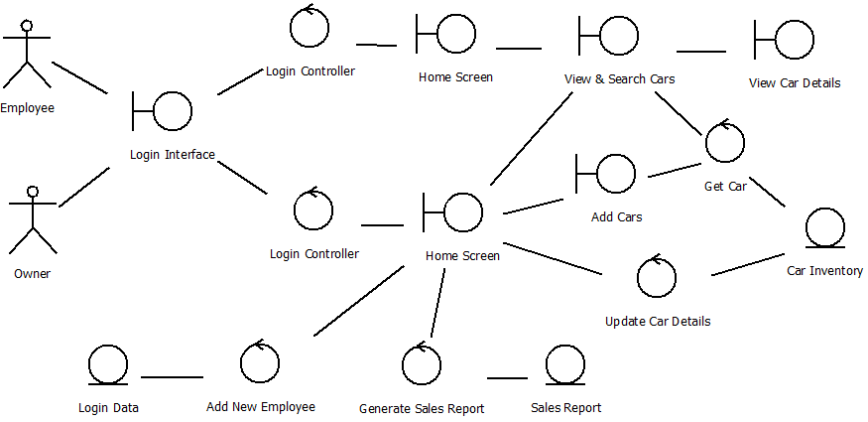

**Activity Diagram**

